N427AB | 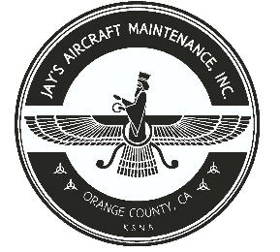  2980 AIRWAY AVE, COSTA MESA, CA 92626  TEL: 714-433-2275, WWW.JAYSAIRCRAFT.COM  FAA APPROVED REPAIR STATION # JVYR016L |  | DATE: 12/9/2019
S/N: 4636324 |  |  | W.O.#: 23459
MODEL: PA46-350P |  |  | TSMOH:
TACH TIME: |  |  | TOTAL TIME: 2126.0
HOBBS TIME: 2126.0
AIRFRAME LOG
THE AIRCRAFT AND / OR COMPONENT IDENTIFIED ABOVE WAS REPAIRED AND INSPECTED IN ACCORDANCE WITH CURRENT FEDERAL AVIATION REGULATIONS AND WAS FOUND AIRWORTHY FOR RETURN TO SERVICE. PERTINENT DETAILS OF THE REPAIR / REPLACEMENT ARE ON FILE AT THIS AGENCY
SIGNED: _____________________________________________________________________________

BLED AND SERVICED BRAKES IAW PIPER PA46-350P SERVICE MANUALS USING MIL-5606-H HYDRAULIC FLUID. OPERATIONAL AND LEAL CHECK FOUND SATISFACTORY.

