N427AB | 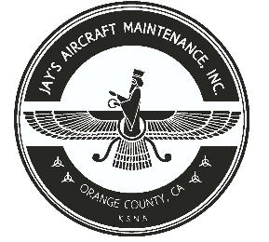  2980 AIRWAY AVE, COSTA MESA, CA 92626  TEL: 714-433-2275, WWW.JAYSAIRCRAFT.COM  FAA APPROVED REPAIR STATION # JVYR016L |  | DATE: 11/26/2019
S/N: L-12384-61A |  |  | W.O.#: 23448
MODEL: TIO-540-AE2A |  |  | TSMOH:
TACH TIME: |  |  | TOTAL TIME: 1492.7
HOBBS TIME: 2125.4
ENGINE LOG
THE AIRCRAFT AND / OR COMPONENT IDENTIFIED ABOVE WAS REPAIRED AND INSPECTED IN ACCORDANCE WITH CURRENT FEDERAL AVIATION REGULATIONS AND WAS FOUND AIRWORTHY FOR RETURN TO SERVICE. PERTINENT DETAILS OF THE REPAIR / REPLACEMENT ARE ON FILE AT THIS AGENCY
SIGNED: _____________________________________________________________________________

SERVICED WITH 12 QTS OF AEROSHELL W100 AND CH48103-1 OIL FILTER. AOA TAKEN. SERVICED WITH LYCOMING ADAPTIVE P/N LW-16702. ENGINE WASHED, RUN UP AND INSPECTED. OPERATIONAL CHECK SATISFACTORY.
R&R SPARK PLUGS WITH NEW P/N URHB36S (12) IAW LYCOMING TIO-540 AND PIPER PA46-350P SERVICE MANUALS. OPERATIONAL CHECK FOUND SATISFACTORY.

