N427AB | 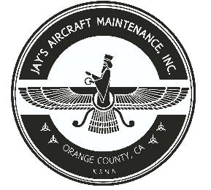  2980 AIRWAY AVE, COSTA MESA, CA 92626  TEL: 714-433-2275, WWW.JAYSAIRCRAFT.COM  FAA APPROVED REPAIR STATION # JVYR016L |  | DATE: 10/19/2020
S/N: L-12384-61A |  |  | W.O.#: 23913
MODEL: TIO-540-AE2A |  |  | TSMOH:
TACH TIME: |  |  | TOTAL TIME: 1635.9
HOBBS TIME: 2268.6
ENGINE LOG
THE AIRCRAFT AND / OR COMPONENT IDENTIFIED ABOVE WAS REPAIRED AND INSPECTED IN ACCORDANCE WITH CURRENT FEDERAL AVIATION REGULATIONS AND WAS FOUND AIRWORTHY FOR RETURN TO SERVICE. PERTINENT DETAILS OF THE REPAIR / REPLACEMENT ARE ON FILE AT THIS AGENCY
SIGNED: _____________________________________________________________________________

COMPRESSION CHECKED.

1. 60/80, 2. 62/80, 3. 78/80, 4. 78/80, 5. 72/80, 6. 68/80

MASTER ORIFICE VALUE: 42

