N427AB | 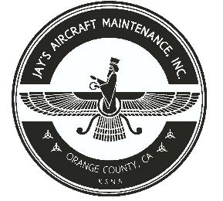  2980 AIRWAY AVE, COSTA MESA, CA 92626  TEL: 714-433-2275, WWW.JAYSAIRCRAFT.COM  FAA APPROVED REPAIR STATION # JVYR016L |  | DATE: 6/3/2020
S/N: 4636324 |  |  | W.O.#: 23695
MODEL: PA46-350P |  |  | TSMOH:
TACH TIME: |  |  | TOTAL TIME: 2156.8
HOBBS TIME: 2156.8
AIRFRAME LOG
THE AIRCRAFT AND / OR COMPONENT IDENTIFIED ABOVE WAS REPAIRED AND INSPECTED IN ACCORDANCE WITH CURRENT FEDERAL AVIATION REGULATIONS AND WAS FOUND AIRWORTHY FOR RETURN TO SERVICE. PERTINENT DETAILS OF THE REPAIR / REPLACEMENT ARE ON FILE AT THIS AGENCY
SIGNED: _____________________________________________________________________________

TROUBLESHOT CABIN PRESSURIZATION IAW PIPER PA46-350P SERVICE MANUAL. FOUND ALL CABIN ORIFICES SEALED AS REQUIRED. PRESSURIZATION TEST FOUND LEAK ON R/H SIDE INTERCOOLER CLAMP. R&R R/H SIDE INTERCOOLER CLAMP WITH NEW IAW LYCOMING TIO-540 AND PIPER PA46-350P SERVICE MANUAL. OPERATIONAL AND LEAK CHECK FOUND SATISFACTORY.

