N427AB | 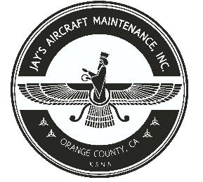  2980 AIRWAY AVE, COSTA MESA, CA 92626  TEL: 714-433-2275, WWW.JAYSAIRCRAFT.COM  FAA APPROVED REPAIR STATION # JVYR016L |  | DATE: 6/7/2018
S/N: L-11015-61A |  |  | W.O.#: 22731
MODEL: TIO-540-AE2A |  |  | TSMOH:
TACH TIME: |  |  | TOTAL TIME:
HOBBS TIME: 2100.3
ENGINE LOG
THE AIRCRAFT AND / OR COMPONENT IDENTIFIED ABOVE WAS REPAIRED AND INSPECTED IN ACCORDANCE WITH CURRENT FEDERAL AVIATION REGULATIONS AND WAS FOUND AIRWORTHY FOR RETURN TO SERVICE. PERTINENT DETAILS OF THE REPAIR / REPLACEMENT ARE ON FILE AT THIS AGENCY
SIGNED: _____________________________________________________________________________

SERVICED WITH 12 QTS OF AEROSHELL 15W-50 AND CH48103-1 OIL FILTER. AOA TAKEN. ENGINE WASHED, RUN UP AND INSPECTED. OPERATIONAL CHECK SATISFACTORY.

