N427AB | 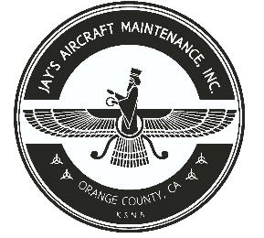  2980 AIRWAY AVE, COSTA MESA, CA 92626  TEL: 714-433-2275, WWW.JAYSAIRCRAFT.COM  FAA APPROVED REPAIR STATION # JVYR016L |  | DATE: 9/23/2020
S/N: HK560A |  |  | W.O.#: 23824
MODEL: HC-I3YR-1E/ 7890K |  |  | TSMOH: 693.3
TACH TIME: |  |  | TOTAL TIME:
HOBBS TIME: 2248.9
PROPELLER LOG
THE AIRCRAFT AND / OR COMPONENT IDENTIFIED ABOVE WAS REPAIRED AND INSPECTED IN ACCORDANCE WITH CURRENT FEDERAL AVIATION REGULATIONS AND WAS FOUND AIRWORTHY FOR RETURN TO SERVICE. PERTINENT DETAILS OF THE REPAIR / REPLACEMENT ARE ON FILE AT THIS AGENCY
SIGNED: _____________________________________________________________________________

C/W ANNUAL INSPECTION IAW PIPER PA46-350P MAINTENANCE MANUAL.
C/W ANNUAL INSPECTION IAW HARTZELL MAINTENANCE MANUAL.
SOME SBS THAT APPLY TO THIS AIRCRAFT MAY NOT HAVE BEEN PERFORMED PER OWNER'S DECISION.
C/W ALL APPLICABLE ADS THROUGHOUT THIS DATE.

