N427AB | 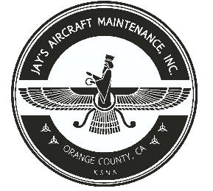  2980 AIRWAY AVE, COSTA MESA, CA 92626  TEL: 714-433-2275, WWW.JAYSAIRCRAFT.COM  FAA APPROVED REPAIR STATION # JVYR016L |  | DATE: 6/7/2018
S/N: 4636324 |  |  | W.O.#: 22731
MODEL: PA46-350P |  |  | TSMOH:
TACH TIME: |  |  | TOTAL TIME:
HOBBS TIME: 2100.3
AIRFRAME LOG
THE AIRCRAFT AND / OR COMPONENT IDENTIFIED ABOVE WAS REPAIRED AND INSPECTED IN ACCORDANCE WITH CURRENT FEDERAL AVIATION REGULATIONS AND WAS FOUND AIRWORTHY FOR RETURN TO SERVICE. PERTINENT DETAILS OF THE REPAIR / REPLACEMENT ARE ON FILE AT THIS AGENCY
SIGNED: _____________________________________________________________________________

R&R DOOR CABLE WITH NEW P/N 89630-004 IAW PIPER PA46-350P SERVICE MANUAL RIGGED AS REQUIRED. OPERATIONAL AND SECURITY CHECK FOUND SATISFACTORY.
SERVICED ALL TIRE PSI IAW PIPER PA46-350P SERVICE MANUAL.
SERVICED HYDRAULIC RESERVIOUR WIL MIL-5606-H HYDRAULIC FLUID IAW PIPER PA46-350P. OPERATIONAL AND LEAK CHECK FOUND SATISFACTORY.

