N427AB | 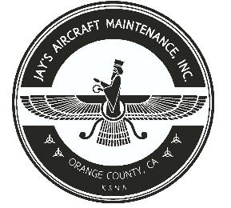  2980 AIRWAY AVE, COSTA MESA, CA 92626  TEL: 714-433-2275, WWW.JAYSAIRCRAFT.COM  FAA APPROVED REPAIR STATION # JVYR016L |  | DATE: 8/13/2020
S/N: L-12384-61A |  |  | W.O.#: 23784
MODEL: TIO-540-AE2A |  |  | TSMOH:
TACH TIME: |  |  | TOTAL TIME: 1591.9
HOBBS TIME: 2224.6
ENGINE LOG
THE AIRCRAFT AND / OR COMPONENT IDENTIFIED ABOVE WAS REPAIRED AND INSPECTED IN ACCORDANCE WITH CURRENT FEDERAL AVIATION REGULATIONS AND WAS FOUND AIRWORTHY FOR RETURN TO SERVICE. PERTINENT DETAILS OF THE REPAIR / REPLACEMENT ARE ON FILE AT THIS AGENCY
SIGNED: _____________________________________________________________________________

SERVICED WITH 12 QTS OF AEROSHELL W100 AND CH48103-1 OIL FILTER. AOA TAKEN. SERVICED WITH LYCOMING ENGINE ADDITIVE LW-16702. ENGINE WASHED, RUN UP AND INSPECTED. OPERATIONAL CHECK SATISFACTORY.

