N427AB | 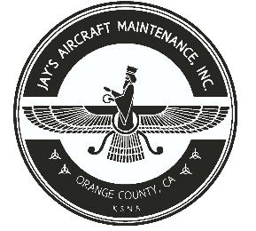  2980 AIRWAY AVE, COSTA MESA, CA 92626  TEL: 714-433-2275, WWW.JAYSAIRCRAFT.COM  FAA APPROVED REPAIR STATION # JVYR016L |  | DATE: 5/26/2020
S/N: L-12384-61A |  |  | W.O.#: 23670
MODEL: TIO-540-AE2A |  |  | TSMOH:
TACH TIME: |  |  | TOTAL TIME: 1517.2
HOBBS TIME: 2149.9
ENGINE LOG
THE AIRCRAFT AND / OR COMPONENT IDENTIFIED ABOVE WAS REPAIRED AND INSPECTED IN ACCORDANCE WITH CURRENT FEDERAL AVIATION REGULATIONS AND WAS FOUND AIRWORTHY FOR RETURN TO SERVICE. PERTINENT DETAILS OF THE REPAIR / REPLACEMENT ARE ON FILE AT THIS AGENCY
SIGNED: _____________________________________________________________________________

TROUBLESHOT ROUGH RUNNING ENGINE AND FOUND INOP L/H MAGNETO. R&R L/H MAGNETO P/N 6363, S/N 11010692 IAW PIPER PA46-350P, LYCOMING TIO-540, AND SLICK 6300 SERIES SERVICE MANUALS AFTER REPAIRED AND 500 HOUR INSPECTION PERFORMED BY OUTSIDE VENDOR UNDER INVOICE# 49940-1. TIMED MAGNETO AS REQUIRED. OPERATIONAL AND LEAK CHECK FOUND SATISFACTORY.

