N427AB | 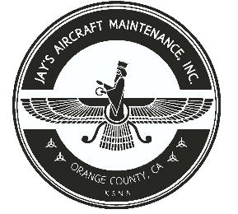  2980 AIRWAY AVE, COSTA MESA, CA 92626  TEL: 714-433-2275, WWW.JAYSAIRCRAFT.COM  FAA APPROVED REPAIR STATION # JVYR016L |  | DATE: 8/26/2019
S/N: HK560A |  |  | W.O.#: 22828
MODEL: HC-I3YR-1E/ 7890K |  |  | TSMOH: 553.3
TACH TIME: |  |  | TOTAL TIME:
HOBBS TIME: 2108.9
PROPELLER LOG
THE AIRCRAFT AND / OR COMPONENT IDENTIFIED ABOVE WAS REPAIRED AND INSPECTED IN ACCORDANCE WITH CURRENT FEDERAL AVIATION REGULATIONS AND WAS FOUND AIRWORTHY FOR RETURN TO SERVICE. PERTINENT DETAILS OF THE REPAIR / REPLACEMENT ARE ON FILE AT THIS AGENCY
SIGNED: _____________________________________________________________________________

C/W ANNUAL INSPECTION IAW PIPER PA46-350P MAINTENANCE MANUAL.
INSTALLED PROPELLER P/N HC-I3YR-1, S/N HK560A ON ENGINE MODEL TIO-540-AE2A, S/N L-12384-61A IAW PIPER PA46-350P, LYCOMING TIO-540, AND HARTZELL #115 SERVICE MANUALS. OPERATIONAL AND LEAK CHECK FOUND SATISFACTORY.
C/W ANNUAL INSPECTION IAW HARTZELL MAINTENANCE MANUAL.
SOME SBS THAT APPLY TO THIS AIRCRAFT MAY NOT HAVE BEEN PERFORMED PER OWNER'S DECISION.
C/W ALL APPLICABLE ADS THROUGHOUT THIS DATE.

