N427AB | 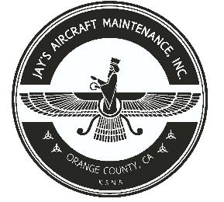  2980 AIRWAY AVE, COSTA MESA, CA 92626  TEL: 714-433-2275, WWW.JAYSAIRCRAFT.COM  FAA APPROVED REPAIR STATION # JVYR016L |  | DATE: 12/9/2019
S/N: L-12384-61A |  |  | W.O.#: 23459
MODEL: TIO-540-AE2A |  |  | TSMOH:
TACH TIME: |  |  | TOTAL TIME: 1493.3
HOBBS TIME: 2126.0
ENGINE LOG
THE AIRCRAFT AND / OR COMPONENT IDENTIFIED ABOVE WAS REPAIRED AND INSPECTED IN ACCORDANCE WITH CURRENT FEDERAL AVIATION REGULATIONS AND WAS FOUND AIRWORTHY FOR RETURN TO SERVICE. PERTINENT DETAILS OF THE REPAIR / REPLACEMENT ARE ON FILE AT THIS AGENCY
SIGNED: _____________________________________________________________________________

R&R SLICK MAGNETO LEFT P/N 6363, S/N 11010692 SLICK MAGNETO RIGHT P/N 6360, S/N 13030858 IAW PIPER PA46-350P, AND LYCOMING TIO-540 SERVICE MANUALS AFTER REPAIRED BY OUTSIDE VENDOR UNDER INVOICE# 48979-80. MAGNETOS TIMED AS REQUIRED. OPERATIONAL AND LEAK CHECK FOUND SATISFACTORY.

