N427AB | 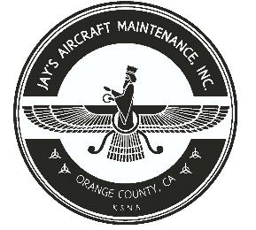  2980 AIRWAY AVE, COSTA MESA, CA 92626  TEL: 714-433-2275, WWW.JAYSAIRCRAFT.COM  FAA APPROVED REPAIR STATION # JVYR016L |  | DATE: 7/17/2020
S/N: 4636324 |  |  | W.O.#: 23755
MODEL: PA46-350P |  |  | TSMOH:
TACH TIME: |  |  | TOTAL TIME: 2200.5
HOBBS TIME: 2200.5
AIRFRAME LOG
THE AIRCRAFT AND / OR COMPONENT IDENTIFIED ABOVE WAS REPAIRED AND INSPECTED IN ACCORDANCE WITH CURRENT FEDERAL AVIATION REGULATIONS AND WAS FOUND AIRWORTHY FOR RETURN TO SERVICE. PERTINENT DETAILS OF THE REPAIR / REPLACEMENT ARE ON FILE AT THIS AGENCY
SIGNED: _____________________________________________________________________________

R&R PROPELLER, ALTERNATOR, ALTERNATOR BELT, AND COMPRESSOR BELT AFTER R&R AIR CONDITIONING COMPRESSOR WITH NEW R134 COMPRESSOR P/N 557-802, S/N 0134011980 AND R&R COMPRESSOR BELT WITH NEW P/N 37B19774-460. SERVICED AIR CONDITIONING SYSTEM WITH 5 CANS OF R134A REFRIGERANT AND COMPRESSOR OIL AS REQUIRED. ALL WORK PERFORMED IAW PIPER PA46-350P SERVICE MANUAL. OPERATIONAL AND LEAK CHECK FOUND SATISFACTORY.

