N427AB | 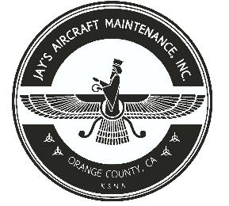  2980 AIRWAY AVE, COSTA MESA, CA 92626  TEL: 714-433-2275, WWW.JAYSAIRCRAFT.COM  FAA APPROVED REPAIR STATION # JVYR016L |  | DATE: 7/1/2019
S/N: HK342A |  |  | W.O.#:
MODEL: HC-I3YR-1E/ 7890K |  |  | TSMOH: 287.6
TACH TIME: |  |  | TOTAL TIME:
HOBBS TIME: 2108.9
PROPELLER LOG
THE AIRCRAFT AND / OR COMPONENT IDENTIFIED ABOVE WAS REPAIRED AND INSPECTED IN ACCORDANCE WITH CURRENT FEDERAL AVIATION REGULATIONS AND WAS FOUND AIRWORTHY FOR RETURN TO SERVICE. PERTINENT DETAILS OF THE REPAIR / REPLACEMENT ARE ON FILE AT THIS AGENCY
SIGNED: _____________________________________________________________________________

REMOVED PROPELLER MODEL HC-I3YR-1E/F890K, S/N HK342A FROM N427AB PIPER MALIBU MIRAGE PA46-350P, S/N 4636324 DUE TO ENGINE REPLACMENT. NO KNOWN DEFECTS AT TIME OF REMOVAL.

