N427AB | 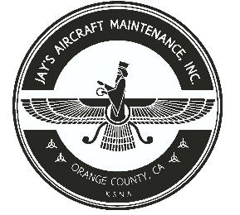  2980 AIRWAY AVE, COSTA MESA, CA 92626  TEL: 714-433-2275, WWW.JAYSAIRCRAFT.COM  FAA APPROVED REPAIR STATION # JVYR016L |  | DATE: 7/19/2018
S/N: L-11015-61A |  |  | W.O.#: 22799
MODEL: TIO-540-AE2A |  |  | TSMOH:
TACH TIME: |  |  | TOTAL TIME:
HOBBS TIME: 2108.9
ENGINE LOG
THE AIRCRAFT AND / OR COMPONENT IDENTIFIED ABOVE WAS REPAIRED AND INSPECTED IN ACCORDANCE WITH CURRENT FEDERAL AVIATION REGULATIONS AND WAS FOUND AIRWORTHY FOR RETURN TO SERVICE. PERTINENT DETAILS OF THE REPAIR / REPLACEMENT ARE ON FILE AT THIS AGENCY
SIGNED: _____________________________________________________________________________

R&R ALL SPARKS PLUGS AFTER CLEANED AND REPLACED GAKETS WITH NEW P/N M674 (12).
INSPECTED IGNITION SYSTEM AND FOUND BROKEN P-LEAD WIRE ON L/H MAGNETO. R&R L/H MAGNETO P-LEAD TERMINAL WITH NEW. OPERATIONAL AND SECURITY CHECK FOUND SATISFACTORY.
R&R OL FILTER WITH NEW P/N CH48103-1 IAW LYCOMING TIO-540 SERVICE MANUAL. FILTER CUT OPEN AND INSPECTED FOR METAL CONTAMINATION. SERVICED WITH LYCOMING ADDATIVE LW16702. FOUND SATISFACTORY. OPERATIONAL AND LEAK CHECK FOUND SATISFACTORY.

